Project Performance Testing Report

Date | 15 July 2026
Team ID
Project Name | Food Ordering Behaviour and Consumer Trends
Maximum Marks

Data Rendered

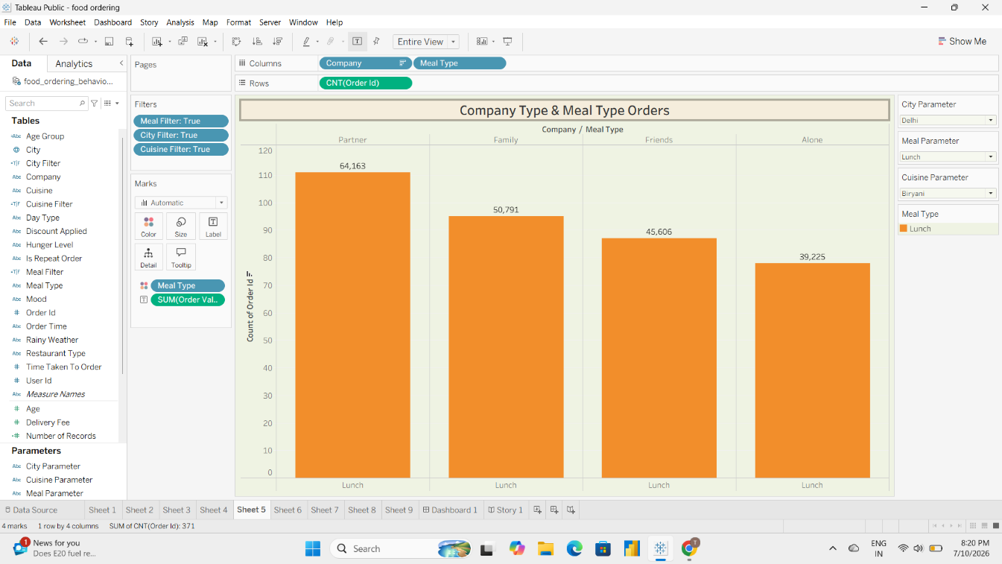

The food ordering dataset was successfully imported into Tableau. All dimensions, measures, and records were rendered correctly, enabling accurate analysis and visualization.

Data Preprocessing

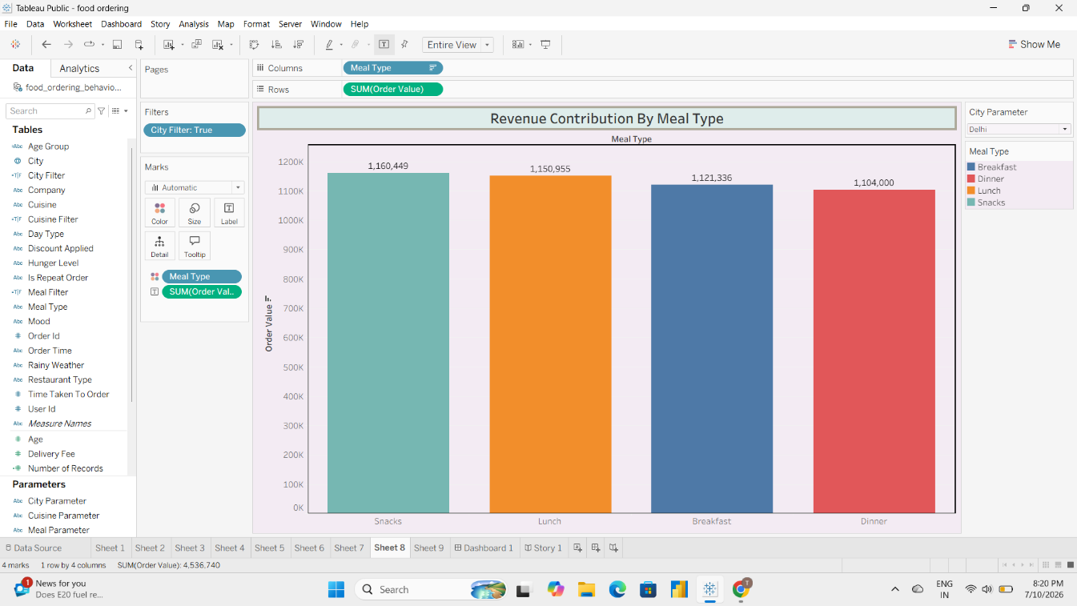
Data preprocessing included validating field types, organizing dimensions and measures, configuring filters and parameters, and preparing the dataset for dashboard development.

Utilization of Filters

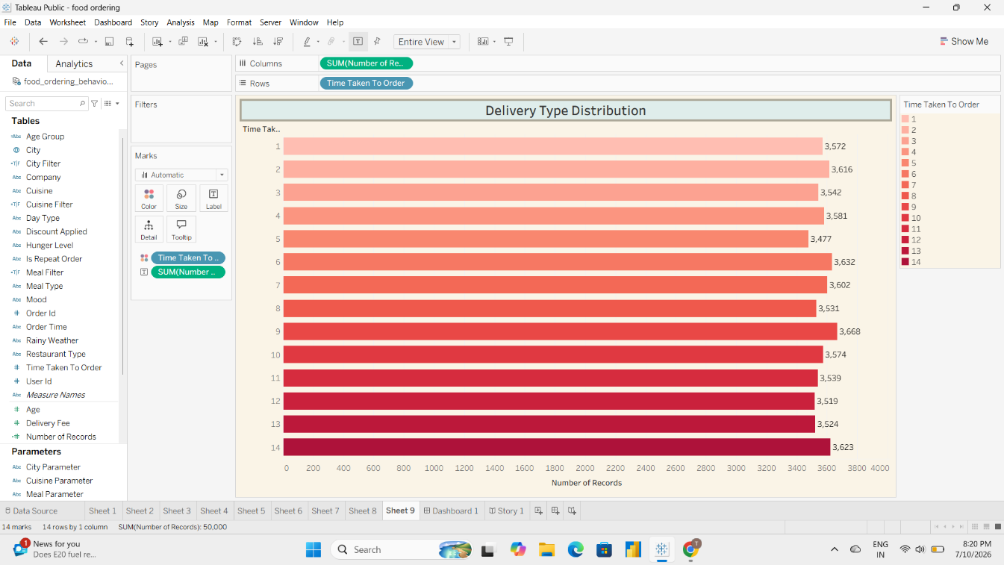

The dashboard uses interactive filters such as City, Cuisine, and Meal Type to allow dynamic exploration of business insights.

Calculation Fields Used

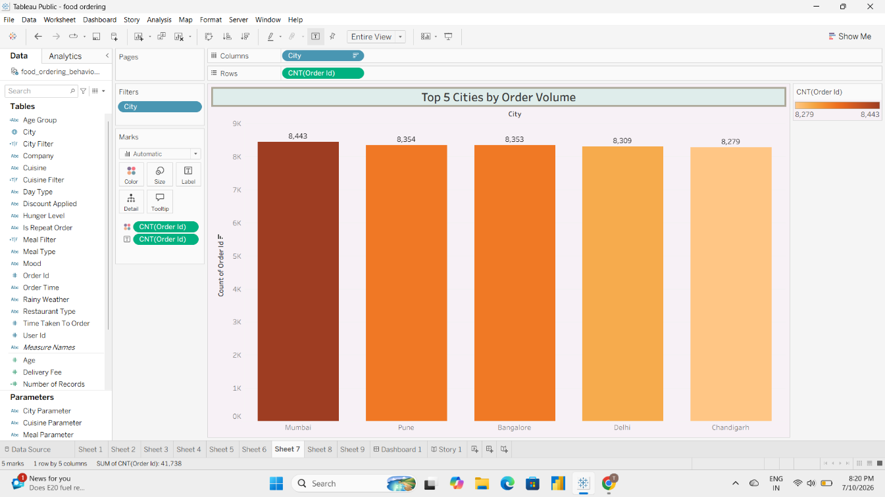

Calculated measures such as Count(Order ID), SUM(Order Value), SUM(Rating Given), and Number of Records were used to generate KPIs and analytical insights.

Dashboard Design

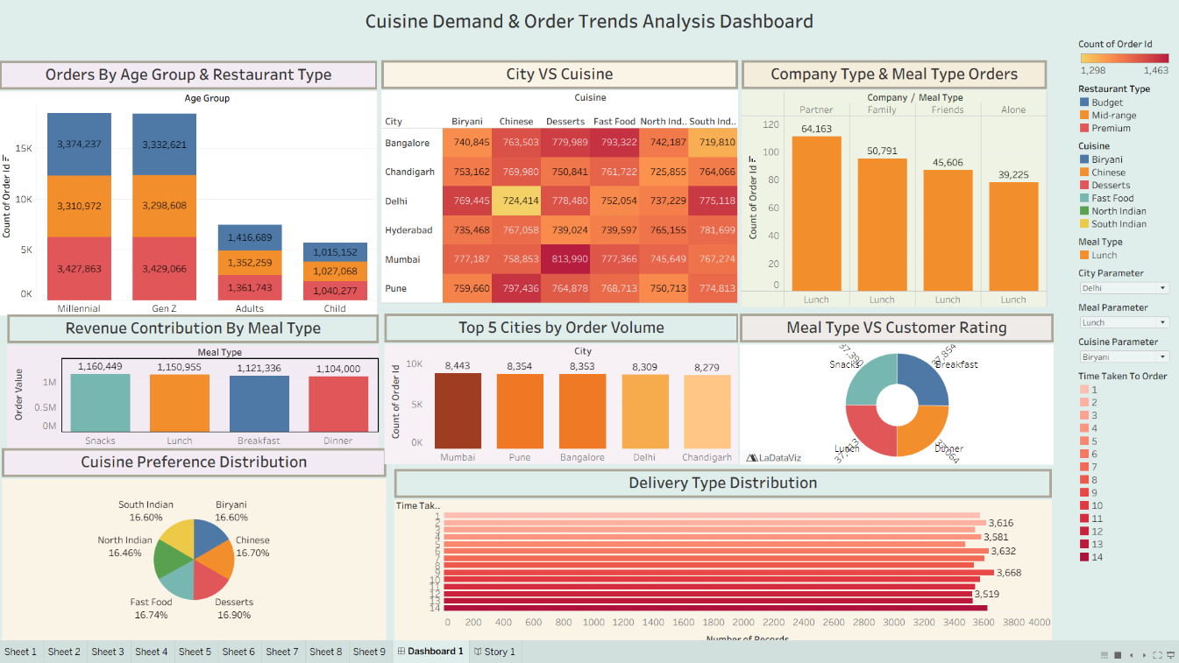

Dashboard Components:
  - Orders by Age Group & Restaurant Type
  - City vs Cuisine Heat Map
  - Company Type & Meal Type Orders
  - Revenue Contribution by Meal Type
  - Top 5 Cities by Order Volume
  - Meal Type vs Customer Rating
  - Cuisine Preference Distribution
  - Delivery Type Distribution Total Visualizations: 8

Story Design

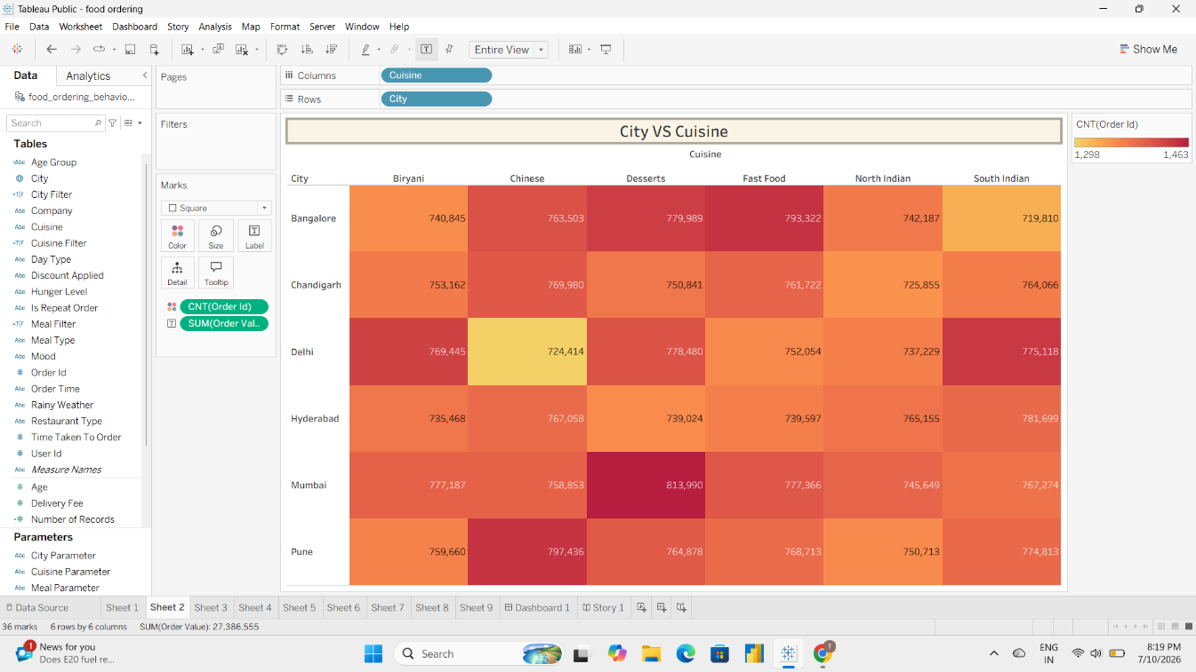

The Tableau Story presents business insights in a structured sequence to help stakeholders

understand trends and make informed decisions. Story Points: 1

Project Outcome
The performance testing phase verified successful data rendering, preprocessing, filter functionality, calculated fields, dashboard responsiveness, and effective story presentation.

